FY2024 Welcome Events Period
OIC Circle Booth Events Recruitment Booklet
Welcome Events Period OIC Circle Booth Events Schedule
April 3 (Wed) & April 4 (Thu) 11:00-16:00

Number of exhibitors: 70 organizations (35 groups × 2 days)

URL：https://forms.gle/PhAGowcfse6oLbrU9
QR code: You can search for the above site from on the right (→).

Contact: oic.circlebooth2024@gmail.com (email)
Publisher: Ritsumeikan University Student Union Central Administrative Office University-wide Events Department

Table of contents

p. 3-5: OIC Circle Booth events
p. 5-6: Reception method
p. 7-9: Flow until exhibition
p. 9-12: Flow on the day of the exhibition
p. 12: About leaflet distribution
p. 13: About sound output
p. 13-14: Prohibitions
p. 15: What to do in case of stormy weather
p. 16-17: Terms and Conditions for Personal Information
p. 18: List of submissions
All the contents are important for the implementation of the circle booth events, so please be sure to check all the items.

About the Welcome Events Period Circle Booth Events

〇What is the Welcome Events Period Circle Booth Events?
This is an event where each organization can introduce the organization within one booth area. Through the circle booth event, we will convey the possibilities and appeal of extracurricular voluntary activities to new students and new second-year students, and to get them interested.

〇 Organization that can carry out planning (all of the following requirements must be satisfied)
・2024 Ritsumeikan University Student Union affiliations, undergraduate project group, or other organization recognized by the university
・The organization must be able to have one exhibitor and two deputy exhibitor managers who are undergraduate students at Ritsumeikan University.
* The maximum number of people in each group who can take part in the circle booth events is 10 people per day.
* It is not possible to concurrently serve as an exhibition manager or deputy exhibition manager with other organizations taking part in the circle booth events, including those on other campuses.
* The person in charge of stage planning cannot concurrently serve as the person in charge of exhibiting or sub-exhibiting in the circle booth events. The person that handles the group event and the group leaflet placement and distribution event can also be the person responsible for the circle booth events or the person responsible for the deputy exhibitor.

〇 Organizations that do not approve of events
・Organizations for profit
・Organizations that engage in antisocial acts (illegal acts, acts that deviate from social common sense)
・Organizations that give or ask for religious or political ideas
・Organizations that engage in discriminatory acts or discriminatory expressions in postings, etc.
・Other organizations that the Ritsumeikan University Student Union Welcome Events Executive Committee (hereinafter referred to as the Welcome Events Executive Committee) and the Ritsumeikan University Student Union Central Administrative Office University-wide Events Department (hereinafter referred to as the University-wide Events Department) consider inappropriate.

〇About the exhibition area
・ Each group is 2.5 m (width) x 2 m (depth).
〇About the person in charge
・Exhibitor manager: Person in charge of circle booth planning. Communicate announcements to participants.
・Deputy Exhibitor Manager: Assists the Exhibitor and acts as a substitute in the absence of the Exhibitor Manager.
*Please be sure to select one exhibitor and two deputy exhibitors.
* On the day of the exhibition, please ensure that one of the exhibitors and the deputy exhibitor is stationed in the booth area of each organization. If it is found that all three people are not present, they will be subject to a point deduction.
* Please select the same person as the exhibitor manager and the deputy exhibitor manager for the organizations showing for two days. It is not necessary to have the same number of participants on both days except for the exhibitor manager and the deputy exhibitor manager.

〇 About the exhibition location
・Symbol Promenade, Campus Promenade (see figure below) 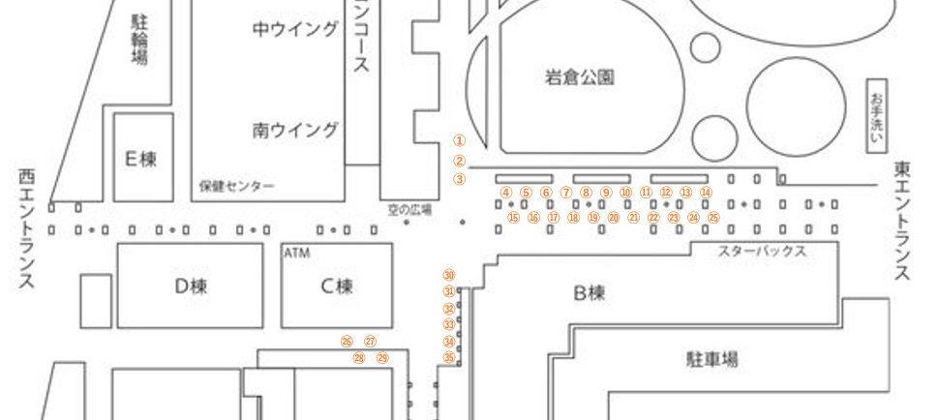
* The layout diagram and number are a guide.
*Subject to change without notice.

〇 Other
・This year's Welcome Events Period OIC Circle Booth Events will be held only on April 3 (Wednesday) and April 4 (Thursday). Plans held on other dates and times are not considered to be the OIC Circle Booth Events.
・If you have any questions, please feel free to contact the University-wide Events Department.
・Please read and strictly follow the information in this booklet.

Reception method

Please note that the reception will be done on the web.

・Organizations that meet the requirements of the regulations (P.3) We will recruit from.
・The reception period is February 26 (Mon) 12:00 - March 4 (Mon) 12:00 . Please apply carefully because it is for a brief period.

Here are the steps:

- Please read the contents of this document carefully (FY2024 Welcome Events Period OIC Circle Booth Events Recruitment Booklet).

- Please access the registration form below during the above registration period.
(The URL of the reception form is also posted on the website of the Student Union.)
URL：https://forms.gle/PhAGowcfse6oLbrU9

- Please fill out the reception form accurately and check it carefully before sending it.
* This year, it will be possible to show on both days only if the number of applicants does not exceed the number of applications. If you would like to take part in the lottery to show on both days, please answer “We would like to exhibit on both days.” in the reception form.
* After sending the reception form, in principle, we will not accept requests from organizations to withdraw their exhibition.

- After the application period ends, the University-wide Events Department will confirm that the application organization follows the application regulations. As soon as it is confirmed, we will use the extracurricular mailing list to send an e-mail to one exhibitor manager and two deputy exhibitor managers of each organization with permission to take part in the lottery.
* Please be sure to check the lottery participation permission email.
* If you have applied and sent your application but have not received the email, please contact the email address listed on the cover.
* It is the responsibility of each organization to check the contents of the email. Make sure you do not miss it.

Flow until exhibition

- lottery
- When the number of applicants exceeds the number of applications
・ While screen recording with the recording function, the University-wide Events Department will draw a fair lottery using the function function of Excel.
・Organizations that are eligible to show because of the lottery will be selected by lottery for the date and location of the exhibition in the same way.
・Groups that are not selected by lottery will be on the waiting list.

- If the number of applicants does not exceed the number of applications
・All organizations that have applied will be able to show on any of the dates.
・After that, we will check the number of remaining slots for recruitment, and from among the organizations that answered “We would like to exhibit on both days” in the reception form, we will draw lots for groups that can show on both days.
・After the groups that will show on both days are decided, a lottery will be held for the exhibition date and place of each group.
・These draws will be conducted fairly by the University-wide Events Department, using the same method as above.
* It is not possible to select the exhibition date, time, and location.

- Sending and receiving lottery result notification emails
We will send an email at the same time after 12: 00 on Friday, March 8.

- Organizations that have been confirmed to exhibit
・Along with the announcement of the availability of exhibits, including the date and location of the exhibition decided by lottery, a pledge (Word file) and a list of exhibitors (Excel file) will be attached to the e-mail. Please download the attached file by 23:59 on Friday, March 15, fill in the required information, and send it by e-mail.

- Groups that did not win the lottery
・We will send you a waitlist number along with a notification of the loss of the lottery.
・The lower the number, the higher the priority of the waiting list (1 is assumed to be the highest priority). In principle, we do not accept requests from organizations to withdraw their exhibitions, but we will allow them to withdraw their exhibits only if the University-wide Events Department figures out that it is extremely difficult to show. If the exhibit is withdrawn, an email will be sent to the organization on the waiting list. If you have received the email, please reply with a date and time when you can call by the date and time listed. Call to see if you would like a vacant slot. The right to wait expires at 23:59 on Friday, March 15.
* If you decline the cancellation slot once, the right to wait will disappear.

- Submission of pledge and list of exhibitors
Groups that have been confirmed to exhibit will download the pledge form (Word file) and exhibitor list (Excel file) attached to the lottery result notification email, fill in the necessary information, and send it on Friday, March 15. Please send an email with the file attached to the oic.circlebooth2024@gmail.com by 23:59 and submit it. In the subject line of the e-mail, please write the Circle Booth Planning Pledge and the list of exhibitors.
*Groups that have been selected to exhibit due to a waitlist must submit their form by 23:59 on Tuesday, March 19 as described above.
*Groups exhibiting for two days are required to submit a total of two exhibitor lists, one for each date. However, the person in charge of exhibiting and the person in charge of sub-exhibiting for each organization must be the same person on both days. Participants can be different for each date.

- guidance
・Date & Time: March 21 (Thu), 22 (Fri) 13:00-15:00
・ Embodiment: Zoom (In principle, please show your face.)
・There are two implementation days, but the guidance content is the same on both days. Therefore, please participate on whichever date is convenient for each group. (Groups that open stores on both days can also participate on only one of the dates.)
・ We will send you an email containing a Google form by the day before the guidance. Please respond on that form with the date you plan to attend the guidance.
・In principle, the attendees will be the exhibitor manager. If the exhibitor manager cannot attend, a substitute deputy exhibitor manager should attend.
・We will check the regulations and prohibitions.
*If one of the exhibitors or deputy exhibitor is unable to participate in the guidance due to unavoidable circumstances, please contact the University-wide Events Department by e-mail by 23:59 on Wednesday, March 20. We will respond individually via Zoom later.
* Please note that if you are absent without permission from the guidance, you will be deducted 3 points from the exhibiting organization's points, and if you are late for more than 10 minutes, you will be deducted 2 points. In that case, as in the case of absence, individual correspondence will be provided later via Zoom.

Flow on the day of the exhibition

- Confirmation of exhibition location
Please check the booth number notified by e-mail and the layout map of the exhibition location and check the booth number marked on the ground with the booth number of each organization at the site.

- Booth setup9:30-11:00
After confirming the exhibition location, please come to the area between Building D and OIC Field to borrow the rental equipment at the proper lending time.
The rental hours are 9:30-10:15 for groups with exhibit numbers (1) - (17), and 10:15-11:00 for groups with exhibit numbers (18) -(35).
Please be sure to bring the student ID card of one of the three exhibitors, one in charge of the exhibition and one in charge of the deputy exhibition. If the submission is not completed, we will not be able to accept the exhibition. The student ID card will be kept at the University-wide Events Department and will be returned to you when you return the equipment.
* The person in charge who deposited the student ID card must come when returning the equipment.

【Rental equipment】
□ One long desk
□ Four pipe chairs
□ One bottle of antiseptic solution
□ One curing tape
□ One Exhibit Permit
□ Two advertising permits
□ Three pieces of vinyl ribbon (Yellow: 1 for exhibitor manager, Blue: 2 for deputy exhibitor manager)
□ One pamphlet on the day (This is a handout, so please do not return it.)

* To be able to carry the equipment to the exhibition location at one time, please come and pick up the equipment with 5 people (including at least 1 person in charge of the exhibition and the deputy person in charge of the exhibition).
* Please attach the exhibition permit so that it can be seen on the front of the desk immediately after borrowing the equipment. We will check it later.
* Desks, chairs, and other equipment owned by the organization can be used freely if it does not deviate from the regulations.
* You do not need to apply to bring in equipment other than rental equipment. However, if the University-wide Events Department deems it inappropriate on the day of the event, we may request the removal of the equipment.
* Damage or dirt to the equipment will be the responsibility of your organization. Be careful when handling equipment.
*11:30-13:00 is expected to be crowded due to new students moving between buildings, so equipment will not be borrowed or returned, so please be sure to come within the designated time.
* To avoid crowding and merging with other groups, the passage is one-way. Please come to the rental location between Buildings C and D.

[Equipment loan chart]
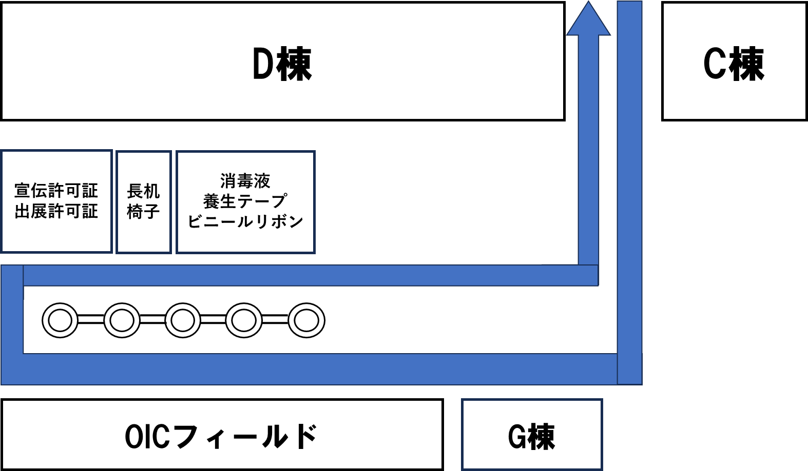

- Circle booth planning starts 11:00-
Please note that if there is no improvement despite receiving a warning for violations, the exhibition may be canceled.

- Circle Booth Finish -16:00
Please withdraw as soon as possible when the exhibition closes at 16:00.
Equipment can be returned until 16:30. You will have to present your exhibition permit when you return it, so please be ready to present it immediately. In addition, the student ID card that was kept at the time of equipment lending can only be returned to the student, so please be sure to return it to the person who submitted the student ID card.
* Returns are possible from 13:00.
In addition, the person responsible for submitting the student ID card must present the questionnaire completion screen. If you do not present it, we will not be able to return your student ID card, so we ask for your cooperation (the questionnaire form is listed on the exhibition permit).

[Return equipment]
□ One long desk
□ Four pipe chairs
□ One bottle of antiseptic solution
□ One curing tape
□ One Exhibit Permit
□ Two advertising permits
□ Three pieces of vinyl ribbon (Yellow: 1 for exhibitor manager, Blue: 2 for deputy exhibitor manager)
* To be able to carry the equipment to the return location at one time, please come to pick up the equipment in 5 people (including at least 1 person in charge of the exhibition and the person in charge of the deputy exhibition).
* To avoid crowding and merging with other groups, the passage is one-way. Please come to the return location between Buildings C and D.

[Equipment return chart]

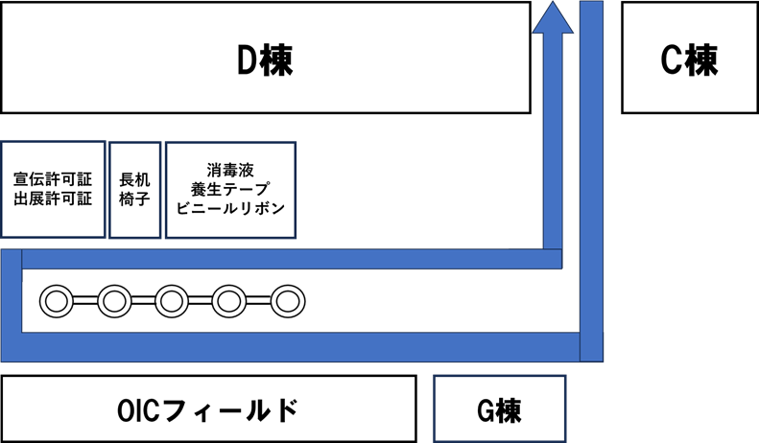

About leaflet distribution

At the circle booth, we will allow you to arrange and distribute leaflets. If you are a group that wants to distribute leaflets in the circle booth events, please submit the leaflets in the group leaflet placement distribution events. The University-wide Events Department will check the content of the information and will only be able to distribute leaflets with permission.

About sound output
Sound production is prohibited in principle. However, it is possible to use a device that does not leak sound, such as headphones, and does not disturb the surroundings. Please note that if it is recognized as inappropriate sound production, points will be deducted.
* There is no time when sound can be played at the OIC Circle booth. No sound is allowed throughout the day.

Prohibitions

As soon as the exhibition is confirmed, all exhibiting organizations will be given 5 points per day, and points will be deducted from the points for each violation. When the number of points reaches 0, the exhibition will be canceled from that date onwards.
* Groups exhibiting for two days will not be able to exhibit on the second day if their exhibition is canceled on the first day.

The following actions are violations. Also, please note that organizations exhibiting on multiple campuses may have different prohibitions and points deductions depending on the campus.

[Minus 2 points]
・ Late without permission of 10 minutes or more of guidance
・Both the exhibitor manager and the deputy exhibitor must leave the booth area.
Improper use of equipment
・ When it goes outside the specified range of the booth
・ When the Exhibitor/Deputy Exhibitor does not wear a vinyl ribbon on the left shoulder
・If you do not follow the instructions of the University-wide Events Department.

[Minus 3 points]
・Even after the first warning, if you have exhibited without presenting your exhibition permit
・Exhibiting at a booth other than the designated booth
・When 11 or more people related to the group enter the booth area
・ Entering and exiting the booth area other than those related to the organization
・Acts that disturb morals
・Acts that interfere with the solicitation of other organizations
・If you have started planning (including distributing leaflets) before the planning start time
・ Unattended booth
・ Solicitation activities for people who do not have an advertising permit by walking around outside the booth
・Distribution of leaflets other than those approved by the University-wide Events Department.
・Aggressive solicitation of new students, new second-year students and above
・Absence without permission for guidance
・Bringing in items that the University-wide Events Department deems inappropriate
・Inappropriate sound production
* It is allowed if it is a device that does not leak sound, such as headphones. In addition, if there is a sound leakage after using headphones, etc., caution will be given for the first time, and 3 points will be deducted for the second and subsequent times.
・If you do not follow the instructions of the University-wide Events Department.

[Cancellation of Exhibition]
・Wearing a costume
・Meals in the booth area
・Drinking alcohol
・Smoking
・When handling dangerous materials such as fire
・Imposition of a specific ideology and proselytizing activities
・Commercial activities
・Antisocial behavior
・Acts that cause inconvenience to neighboring residents
・If you do not follow the instructions of the University-wide Events Department.

Other actions deemed inappropriate by the University-wide Events Department will be noted each time.
In addition, if you do not follow the instructions even after paying attention twice, you will be subject to point deduction and cancellation of the exhibition.

What to do in case of stormy weather

If it is determined that it is difficult to exhibit at the booth on the day of the booth by 12:00 on the day before the booth exhibition date, and it is determined that it will be difficult to exhibit at the booth on the day of the booth, we will notify each organization using the extracurricular mailing list. In addition, new students will be notified on X (formerly Twitter), Instagram, and the special website of Welcome Events. On the day of the event, it will be left to the discretion of each organization to exhibit their booths in the event of rain, but if the University-wide Events Department and the Welcome Events Executive Committee determine that it is difficult to exhibit their booths due to bad weather, all organizations will be suspended from exhibiting.
In the event of a cancellation, the University-wide Events Department will visit the booths of each organization and make a call. Even if it is canceled, it is obligatory for all organizations to return the equipment.

Terms and Conditions for Personal Information
(Purpose)
Article 1
The purpose of this agreement is to protect personal information acquired by the University-wide Events Department (The following are the Department) during its activities.
(Definition)
Article 2
For the purposes of these Terms, “personal information” refers to information that can identify an individual, such as name, address, date of birth, telephone number, e-mail address, and student ID number.
(Responsibilities)
Article 3
This department is responsible for complying with this agreement regarding the protection of personal information.
(Person in charge)
Article 4
As the person responsible for the acquisition of personal information protection in this department, the general manager of this department shall be appointed as the person in charge of managing.
Article 5
The manager shall instruct and supervise the members of this department to ensure that they comply with these terms.
(Safety Management)
Article 6
This department will strictly manage personal information so that it will not be viewed by third parties.
(Purpose of use)
Article 7
This department will use personal information only for operations necessary for planning or planning and operating during the Welcome Events Period.
(Disposal)
Article 8
This department shall promptly dispose of personal information after all the operations stipulated in the preceding article have been completed.
(Provision for third parties)
Article 9
The department will not provide personal information to third parties.
Article 10
Notwithstanding the preceding article, in any of the following cases, the department may provide personal information to a third party.
1. When consent is obtained from the provider
2. When there is a request from the police or a court for disclosure of information related to the investigation of the case
3. When required by law

List of submissions

Check box | Submission date | Documents to be submitted
 | 3/8  ～3/15 | Pledge (Word file)  * Submit as an attachment to an e-mail during the period on the left.
 | 3/8  ～3/15 | List of Exhibitors (Excel file)  * Submit as an attachment to an e-mail during the period on the left.
 | 3/8～3/19  * Groups that have been selected to exhibit due to a waiting list | Pledge (Word file)  * Submit as an attachment to an e-mail during the period on the left.
 | 3/8～3/19  * Groups that have been selected to exhibit due to a waiting list | List of Exhibitors (Excel file)  * Submit as an attachment to an e-mail during the period on the left.

Are there any missing in any documents before submission? Please check again.

Contact: oic.circlebooth2024@gmail.com (email)
Publisher: Ritsumeikan University Student Union Central Administrative Office University-wide Events Department

