Ritsumeikan University Festival 2025
BKC Festival
Application Booklet in Stage Event

Central Stage’s Theme
『翔』

This theme is read as “Kakeru”, and it means that “to spread wings and fly high into the sky” and “to run forward the future”.
This theme was selected with the hope of creating opportunities for each student to perform their individual talents and fly into the future and meaning of moving forward with our feet on the ground, to seek growth and challenge.

Being Stage’s Theme
『Break the Silence』

“Silence” does not express the absence of sound, but an inner stillness before emotions begin to stir. Based on this, the concept is to involve the audience who visited the Being Stage, and have everyone present liven up the stage, we can “break the silence” as a whole.

We look forward to your application！

Implementation Date: Sunday, 16th November 2025
Reception Date: 12p.m. on Wednesday, 20th August 2025
~23:59 on Sunday, 31st August 2025
Reception Method: Google Form (https://forms.gle/ynU5Ddy4DT7WRSCg6)

Central Stage in Ritsumeikan University Festival 2024
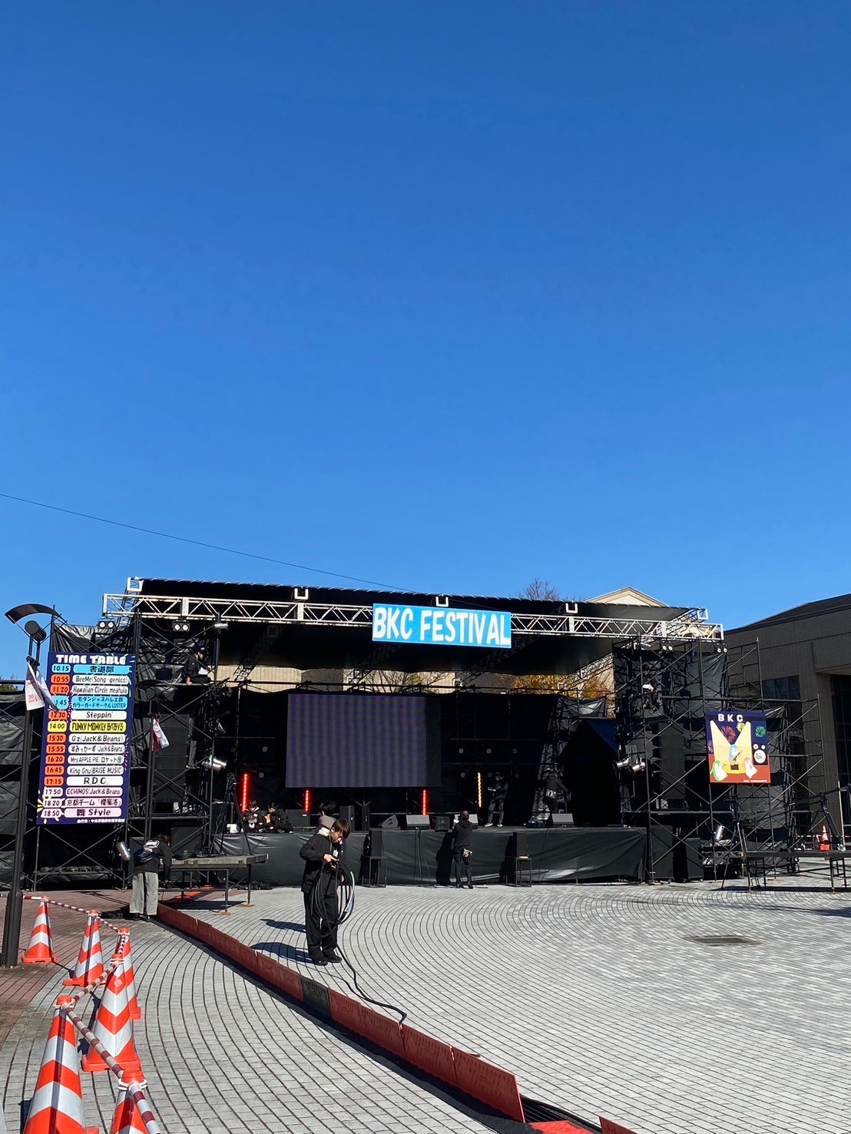

Being Stage in Ritsumeikan University Festival 2024
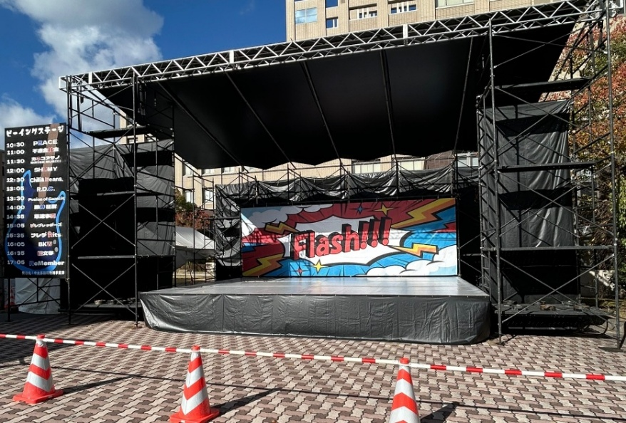
Contents
- Central Stage Event Overview 5

- Being Stage Event Overview 6

- Overall Overview 7

- Prohibitions 8

- Flow of leading up to the performance 8

- Reception 9

- Selection Committee 10

- Hearings 11

- Guidance 12

- Regulations on the Personal Information Protection of the University Festival Events of the Ritsumeikan University Student Union 13

- Contact Information 15

Central Stage Event Overview
Following on from last year, we will be holding the Central Stage Event at the BKC Festival this year. We look forward to your participation in the Central Stage Event!

Rehearsal Day：10:00～19:00 on Saturday, 15th November 2025
Implementation Date：10:10~17:40 on Sunday, 16th November 2025
Location：Central Circus
Size of stage：10.8m×7.2m

Time limit：15 minutes
Conversion time：10 minutes
※This may vary depending on the content of the performance.
Number of recruiting groups：8 groups

【Eligibility to apply】
- The majority of performers must be Ritsumeikan University students.
- The group representative and event manager must be Ritsumeikan University students.
- Organizations must be affiliated with the Ritsumeikan University Student Unio and Central Part.
- The same person must not perform in this Event, the Ending Stage at the BKC, and the Being Stage Event at the BKC.
- The group representative and planning manager must also not oversee other BKC events (Food Booth, Flea market, and Group Event).
All the above requirements must be met.
Being Stage Event Overview
Following on from last year, we will be holding the Being Stage Event at the BKC Festival this year. We look forward to your participation in the Central Stage Event!

Rehearsal Day：10:00～19:00 on Saturday, 15th November 2025
Implementation Date：10:30~17:30 on Sunday, 16th November 2025
Location：Undecided
Size of stage：7.2m×5.4m

Time limit：15 minutes
Conversion time：10 minutes
※This may vary depending on the content of the performance.
Number of recruiting groups：14 groups

【Eligibility to apply】
- The majority of performers must be Ritsumeikan University students.
- The group representative and event manager must be Ritsumeikan University students.
- Organizations must be affiliated with the Ritsumeikan University Student Unio and Central Part.
- The same person must not perform in this Event, the Ending Stage at the BKC, and the Being Stage Event at the BKC.
- The group representative and planning manager must also not oversee other BKC events (Food Booth, Flea market, and Group Event).
All the above requirements must be met.
Overall Overview
【In case of rain】
The Stage has a roof, so the Stage Event will generally be held even in rainy weather. However, the University-wide Events Department, University Festival Executive Committee, Ritsumeikan Univ. Broadcasting Center (RBC), and the organizations (or performers) decide that heavy rain, strong winds, or other reasons make it difficult to carry out the events, it will be cancelled. Please be aware of this in advance.
Some performances may be canceled or suspended by the type of performance and the timing of the decision to cancel.

【Confirmation of performance content by the Student Affairs Division】
Office of Student Affairs will check whether sufficient consideration has been given to safety in the performance. If there are any concerns during the checking, we may hold an interview at any time and decide whether to proceed with the performance.

Prohibitions
- Actions and statements that slander or insult others
- Performances that violate public order and morals
- Actions that violate laws and regulations
- Damage to stage equipment or fixtures
- Any other actions or statements that the University-wide Events Department consider inappropriate
- Actions that interfere with the activities of other events or organizations

- If you violate these rules, we will take strict measures like requiring compensation, canceling your performance at the Stage Event, and suspending applications for the Stage Event from next year onwards. Please be aware of this in advance.

Flow of leading up to the performance
- Reception
For details, please check P.9 “Reception”.
- Selection Committee and announcement of organizations which passed the Selection Committee
For details, please check P.10 “Selection Committee”.
- Hearings
For details, please check P.11 “Hearings”.
- Guidance
For details, please check P.12 “Guidance”.
- Rehearsal
For details, we will inform you during the Hearing.
- Performance

Reception
Reception Date: 12p.m. on Wednesday, 20th August 2025
~23:59 on Sunday, 31st August 2025
Number of recruiting organizations：22 groups
Submission
・Application form (PDF format)
・Pledge form (PDF format)
・List of performers (PDF format)
・Vehicle entry application form (If necessary, PDF format)
・Application for power usage (If necessary, PDF format)
・A copy of the student ID for all performers (If not a Ritsumeikan University student, you need a copy of an ID with a photo, PDF format)
・URL for the Selection Committee video選考会用の映像のURL
・〈By Ritsumeikan Univ. Broadcasting Center (RBC)〉The hearing sheet for band organizations (PDF format)
・〈By Ritsumeikan Univ. Broadcasting Center (RBC)〉The hearing sheet for other than band organizations (PDF format)
・Group introduction photo (JPG format)
※Please use a landscape photo with an aspect ratio of 3:4.
・The hearing desired schedule form (Excel format)

※Cautions※
・Please fill in the required information in the application form, pledge form, and submit them using the application form on the cover.
・If there are any performers who are not Ritsumeikan University students, please submit the photo data of an ID instead of a student ID. However, only the photo data with your face are accepted.
※If it is not clear or if there are any deficiencies, we may be asked to resubmit your photo.
・Please make sure that the group representative and planning manager must also not oversee other BKC events (Food Booth, Flea market, and Group Event).
・Please fill out these documents in a Word file and convert them to the specified file format. After that, please submit them at the Google form (https://forms.gle/ynU5Ddy4DT7WRSCg6).

Selection Committee
Performing organizations will be selected by the Selection Committee.
Members of performing organizations do not need to participate in the Selection Committee.
At the same time, the contents of performance will be confirmed by the stage planner of the University-wide Events Department and RBC.
※The Office of Student Affairs will be responsible for checking the safety of the content of performance.

Implementation Date: Tuesday, 2nd September 2025
Method of judging: The video date and documents which are submitted at the time of reception will be reviewed by the University-wide Events Department and the stage staff of RBC.

Judging items :1. Selection Criteria for members of the University-wide Events Department
- Perfection of performance (25 points)
- Suitability of the University Festival (25 points)
- Completeness of documents (15 points)
- Points will be deducted for violations of rules during the stage performance of last year’s University Festival.
※Points will be deducted from the total scores of all selected applicants. (Maximum of 5 points)

2. Selection Criteria for members of RBC
- Perfection of performance (25 points)
- Perspective to consider when running the events (15 points)

The content of your video data
・Please make sure the content is as same to the actual performance as possible.
・Please select songs of performance like those used on the event day.
・Please do not edit the video excessively.
・Please submit the video data on the application form.
・Your video data will also be considered for Selection Committee.

Announcement of organizations passed the Selection Committee
：From Tuesday, 2nd September
- Organizations passed by the Selection Committee will be announced by contact
(e-mail or phone).
If you did not pass, we will contact you by e-mail.
The scoring results will not be made public. Please be aware of this in advance.

Hearings
You will have two meetings with the stage manager and members of RBC staff to discuss your performance. The dates will be determined based on your hope at the time of reception. Participation by either the organization representative or the planning manager is required. If you are unable to attend, please contact us by e-mail.

Dates：
Session1 Wednesday, 3rd September – Wednesday, 10th September 2025, 9:00～18:00
Session2 Tuesday, 16th September – Sunday, 21st, September 2025, 9:00～18:00

Format
Session1：In-person
Session2：Microsoft Teams
※Until last year, the session was held by Zoom, but it will be held by Microsoft Teams from this year.

Things to confirm during the hearings
・Content of performance
・Content of interview
・Rehearsal information
・Flow of leading up to the performance
※Details will be sent by e-mail when Organizations passed by the Selection Committee announced.

Guidance
The staff manager will provide performers with an explanation of “caution when performing” and “rehearsal information and flow of leading up to the performance”. The guidance will contain important information to ensure smooth running, so all performers must attend, as a rule.
After the guidance, we will conduct a survey to check your understanding of the content. For people who were unable to attend due to unavoidable circumstances, or attended but had questions, we will send you a guidance video later.

Date：18:25～19:25 on Tuesday, 4th November 2025
Format：In-person

Target：Performers
- Participation is mandatory for each organization leader and planning manager.
- Attendance by more than two-thirds of the performers from each organization is required.
- If the attendance is less than two-thirds, points will be deducted from the Selection Committee for the following year.
- If you notify us at least two days that members of your organization will be unable to attend more than two-thirds due to a valid reason, such as participating in a tournament, your organization will not be deducted for the following year. However, if you do not notify us or your reason is not deemed valid, points will be deducted.
- Details will be explained during the hearings.

Regulations on the Personal Information Protection of the University Festival Events of the Ritsumeikan University Student Union
Chapter 1 General Provisions
Article 1 (Purpose)
The purpose of this regulation is to ensure the proper treatment and protection of information collected during the University Festival organized by the Ritsumeikan University Student Union. In addition, this regulation establishes the basic policy concerning personal information protection and specific guidelines for management and running based on the "Rules on University Festival Events of the Ritsumeikan University Student Union".
Article 2 (Definitions)
In this regulation, "personal information" refers to the "personal information" as defined by the Personal Information Protection Law, which includes information such as name, affiliated faculty, academic year, date of birth, telephone number, e-mail address, student ID number, and any other information that can identify a specific individual.

Chapter 2 Management System
Article 3 (Management Responsibility)
The person responsible for managing personal information is the chairperson of the University Festival Executive Committee for that year. However, if an organization within the Ritsumeikan University Student Union is responsible for the practical aspects based on the policies set by the University Festival Executive Committee, the leader of that organization shall be designated as the practical personal information officer, ensuring proper management of personal information in cooperation with the University Festival Executive Committee.
Article 4 (Duties of the Management Responsibility Person)
The management responsibility person has the following duties to ensure the proper treatment of personal information:
- Thorough dissemination of this regulation
- Guidance and supervision of Ritsumeikan University Student Union members involved in the University Festival
- Appropriate management of the collection, storage, use and disposal of information
- Prevention of information leaks, losses, and alterations, as well as establishment of a reporting system
- Appropriate coordination with practical personal information treatment officers and the establishment and treatment of an information management system

Chapter 3 Management of Collection, Use, and Storage of Personal Information
Article 5 (Limitations on Collection)
The collection of personal information is limited to the scope necessary for the University Festival, and the purpose of use is clearly stated in advance.
Article 6 (Limitations on Use of purposes)
The collected personal information is only used for the purposes specified in the following items:
- Contact and coordination regarding the practical aspects of University Festival planning
- Notification and management for participating organizations
- Necessary business processing such as creating various lists and issuing certificates
- Emergency contact and response in case of incidents
- Other legitimate purposes related to the University Festival
Article 7 (Storage and Disposal)
Personal information is disposed of promptly and appropriately after achieving the purpose of use. However, if a portion is to be retained for legitimate record-keeping purposes such as activity records and reports, it may be stored under the responsibility of the chairperson of the University Festival Executive Committee, and if an Organization within the Ritsumeikan University Student Union is responsible for the practical aspects, it can be stored for a maximum of three years under strict management.

Chapter 4 Provision to Third Parties and Corrections
Article 8 (Limitation on Provision to Third Parties)
Personal information is not provided to third parties except in the following cases:
- When there is consent from the individual
- As required by law
- In urgent situations necessary to protect a person's life, body, or property, where obtaining consent from the individual is difficult
- When cooperation is necessary with national agencies or local governments, or individuals executing duties based on law under delegation, and obtaining consent from the individual could hinder the execution of those duties
Article 9 (Requests for Correction, Deletion)
If a request for disclosure, correction, suspension of use, or deletion of personal information concerning oneself is made to the person responsible for managing personal information by the individual or their representative, it responded promptly.

Chapter 5 Amendments
Article10 (Amendment Procedure)
Amendments to these regulations are carried out by a proposal from the University Festival Executive Committee, followed by a decision based on a majority vote of the members attending at the Central Standing Committee and the Central Secretariat Office.

Supplementary Provisions
- These regulations have been taken effect from June 21, 2025.
- The provisions of these regulations are also applied to personal information collected before the enforcement of these regulations.
- In the treatment of these regulations, if an organization within the Ritsumeikan University Student Union involved in the University Festival has its own provisions regarding personal information protection, such provisions do not hinder the operation of these regulations if they do not contradict and can coexist with them.
- Matters not stipulated in these regulations are governed by the "Regulations on Personal Information Protection of the Ritsumeikan University Student Union."

Contact Information
Ritsuneikan University Student Union Central Secretariat Office University-wide Events Department: Stage Events manager
Location：Ritsumeikan University BKC Central Arc 4th floor Central Act Office
e-mail: ibedistage@gmail.com

